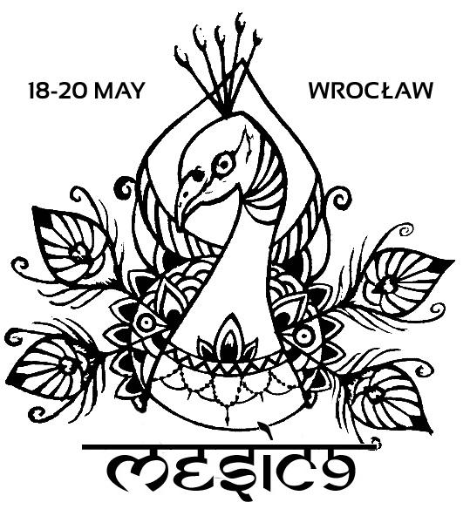

Dear Students, Colleagues, Friends,
It is already the ninth time we will have the opportunity to meet each other at the Middle European Student Indology Conference! Department of Indian Studies of the University of Wroclaw, Students' Association ‘Interdisciplinary Oriental Circle’ and students of Wratislavian Indology are pleased to invite you to take part in the 9th Middle European Student Indology Conference (MESIC 9). This year, the Conference will be held in Wrocław, from 18th to 20th May 2017.
Middle European Student Indology Conference (MESIC) was initiated by students of the University of Zagreb, Adam Mickiewicz University in Poznań and the University of Wrocław. It is an almost nine-year long tradition, which began in 2009. This year, it is the third time, when MESIC will be organized in Wrocław by students for students (also doctoral students). It will be a great opportunity to share and discuss our common interests connected with Indian languages, literature, and culture.
During the Conference, the participants will present topics ranging from ancient to modern India, from linguistics to literature. The expected total time for presentation will be 30 minutes (20-minute paper presentation and 10-minute discussion). Anyone who is interested in presenting a paper is required to send us a written abstract up to 300 words. The last day to submit the abstracts is 15th March 2017. Please send them to:
mesic9.wroclaw@gmail.com
The results will be announced by 10th April 2017. We reserve the right to limit the number of presentations.
The language of the conference shall be English.
Organizers of the conference are: the Department of Indian Studies’ students and the Interdisciplinary Oriental Circle.

REGISTRATION AND ACCOMODATION
All participants of MESIC 9 will be required to pay a conference fee of 130 złotych (PLN) (30€) and send us the confirmation of attendance form (attached to this e-mail) up to 20th April 2017.
The fee covers accommodation (3 nights), the conference materials, 3 lunches, an official dinner and refreshments during the three-day event.
Please, pay the fee:
- in Euro on: PL 20 1090 2398 0000 0001 3379 4038
SWIFT: WBKPPLPP
- in polish zloty on: 20 1090 2398 0000 0001 3379 4038
CONTACT: mesic9.wroclaw@gmail.com

We’re looking forward to seeing you in Wroclaw soon!
The Organisers of MESIC 9

